**OUTREACH REPORTING SYSTEM**

**Application Git Repository Url:**

**Frontend:** [**http://172.18.2.18/scorpion/690784-Hackathon-FrontEnd**](http://172.18.2.18/scorpion/690784-Hackathon-FrontEnd)

**Backend:** [**http://172.18.2.18/scorpion/690784-Hackathon-BackEnd**](http://172.18.2.18/scorpion/690784-Hackathon-BackEnd)

**Technolgies Used to develop this project**

**Frontend**: Angular7, Bootstrap, Core UI, Prime ng, am chart for chart creation

**Backend:** Asp.net core 2.2, EF core 2.2

**DataBase:** Sql server

**Unit Test:** Jasmine, Xunit

**Application Features:**

**Application Modules:** Application consists 5 modules

* Dashboard
* Reports
  + Participation Report
  + Engagement Report
  + Retention Report
  + Acquisition Report
  + General report
* File Upload
* Users
* Settings

**Application users:** 3 roles of users can access this application

**Roles:** Admin, PMO & POC

**Application super admin login credentials:**

**Associate ID:** 123456

**Email:** [admin@cognizant.com](mailto:admin@cognizant.com)

**Admin user can access all modules of application:**

* View dashboard which contains overall data
* View/download all reports
* Upload application inputs – 3 types of input data
* Add/upload application user details

**PMO user can access only below modules (Admin will add PMO details via UI)**

* View dashboard
* View/download all reports

**POC user have access only to the particular event for which he is the POC:**

* View dashboard
* View/download all reports

**Dashboard Screen:**

Will have overall report of Associates, Volunteers and events.

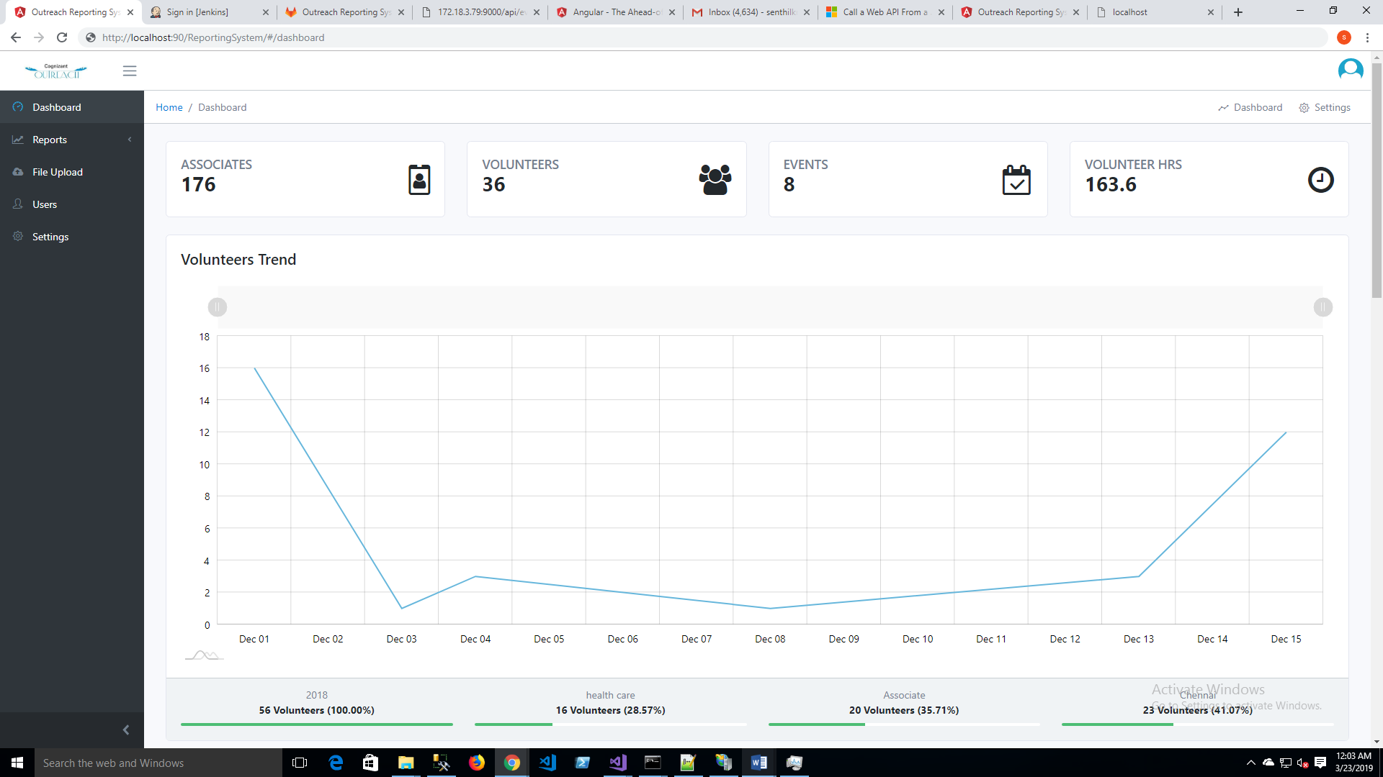

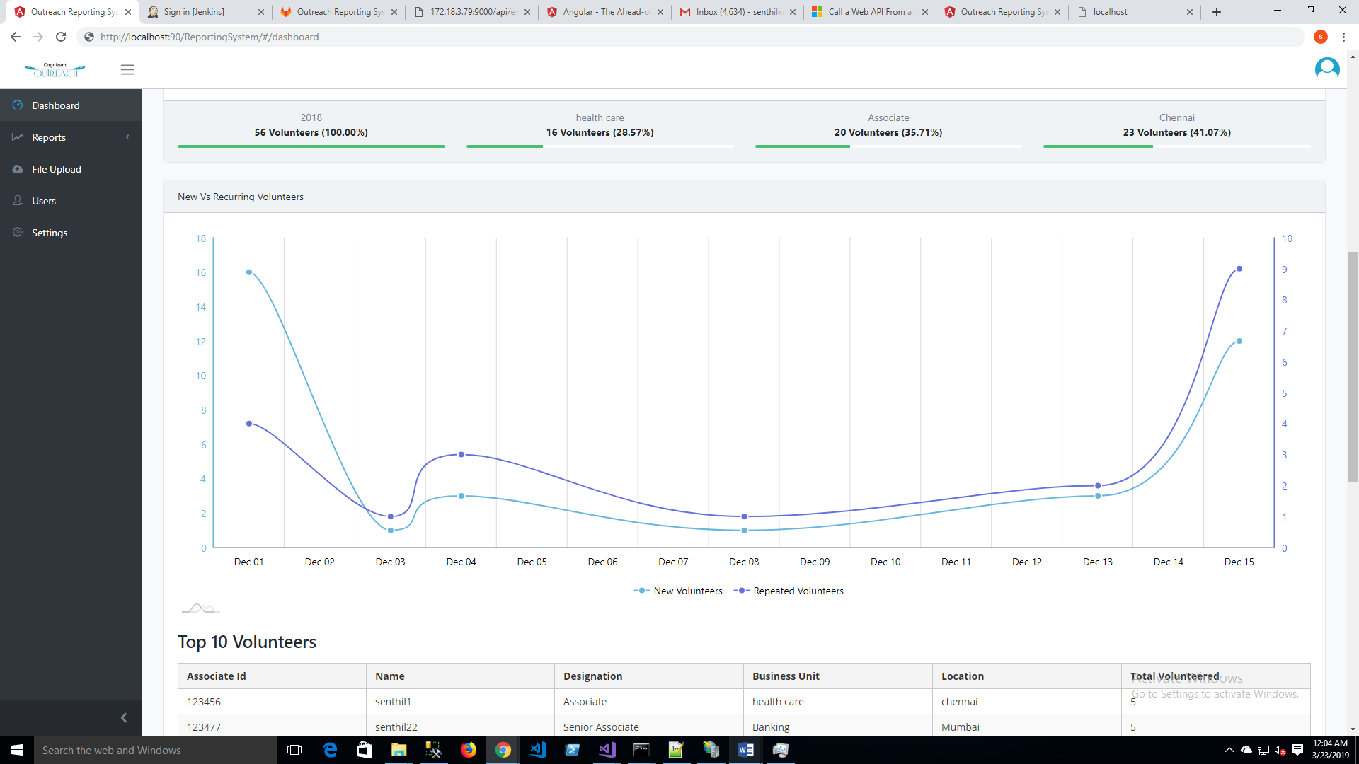

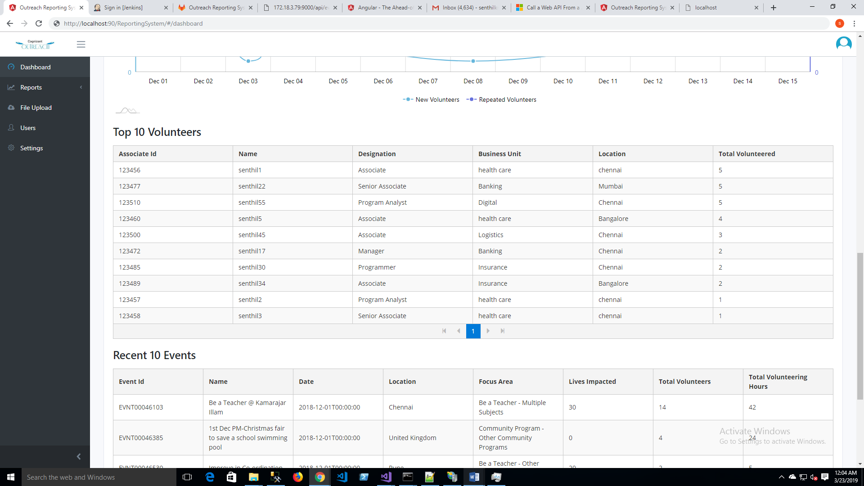

**Participation Report Screen:**

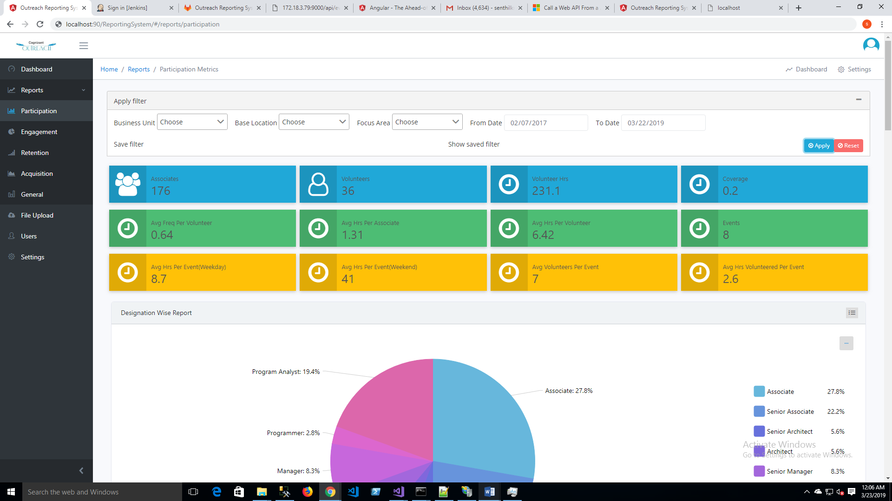

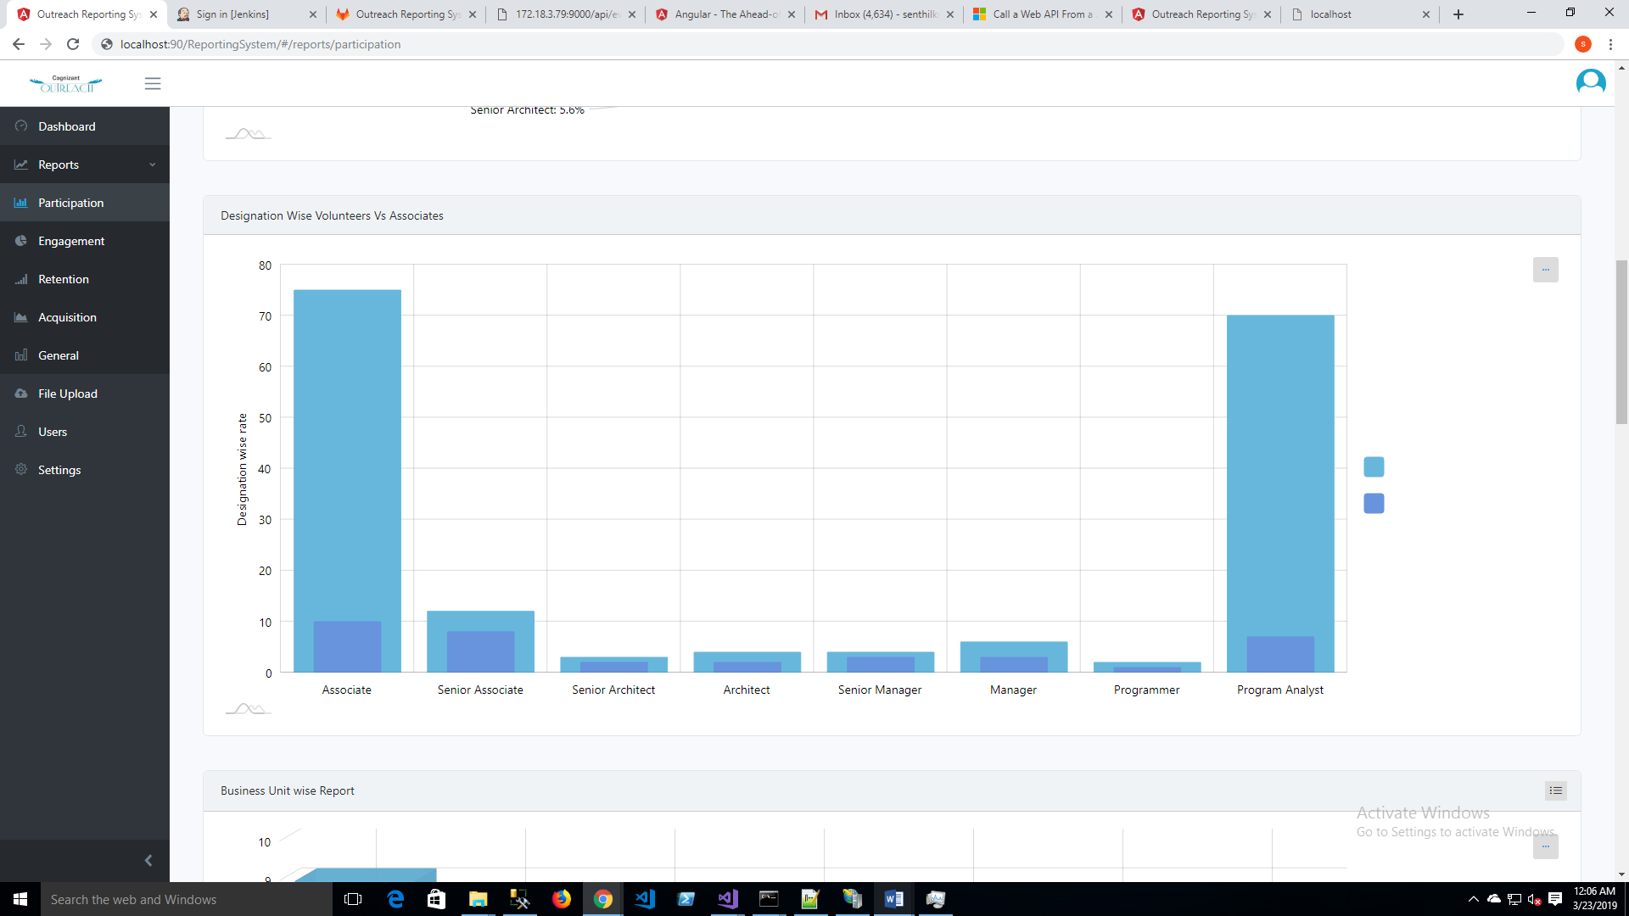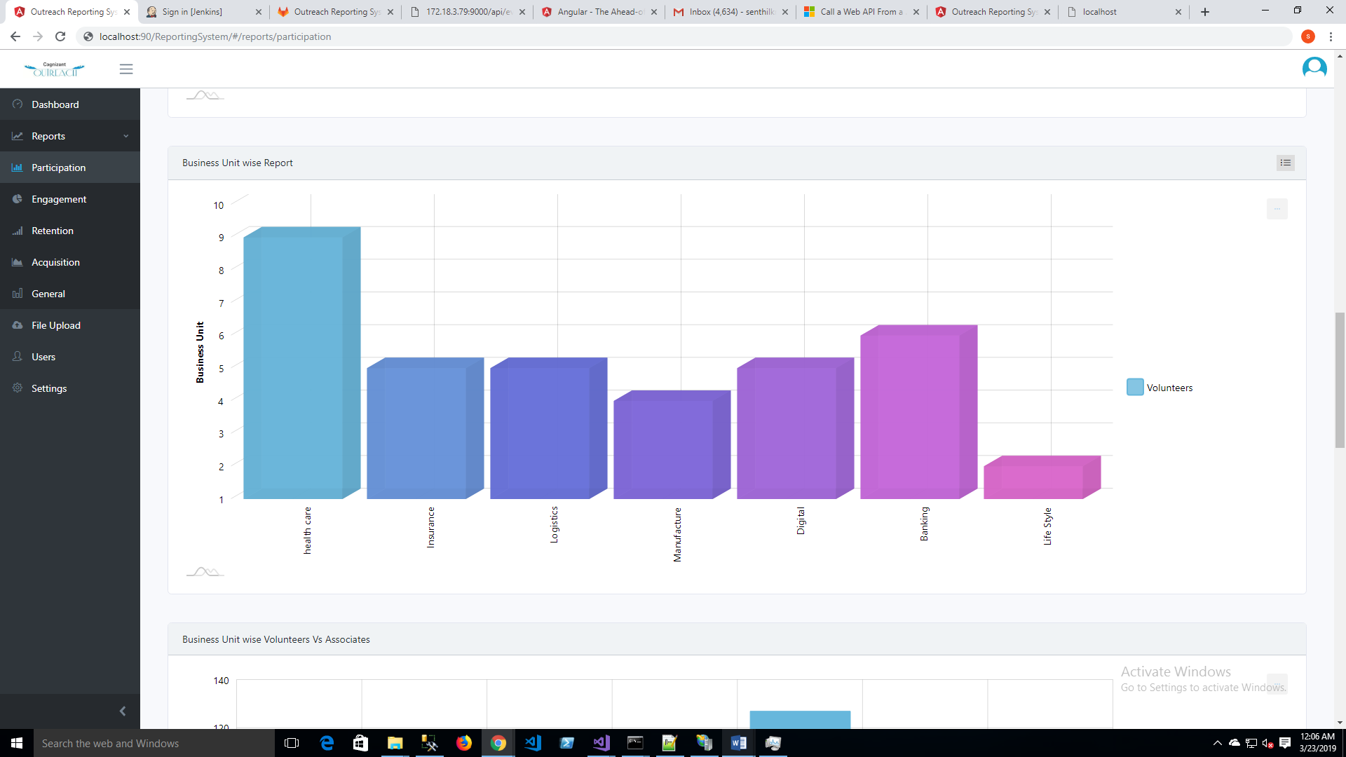

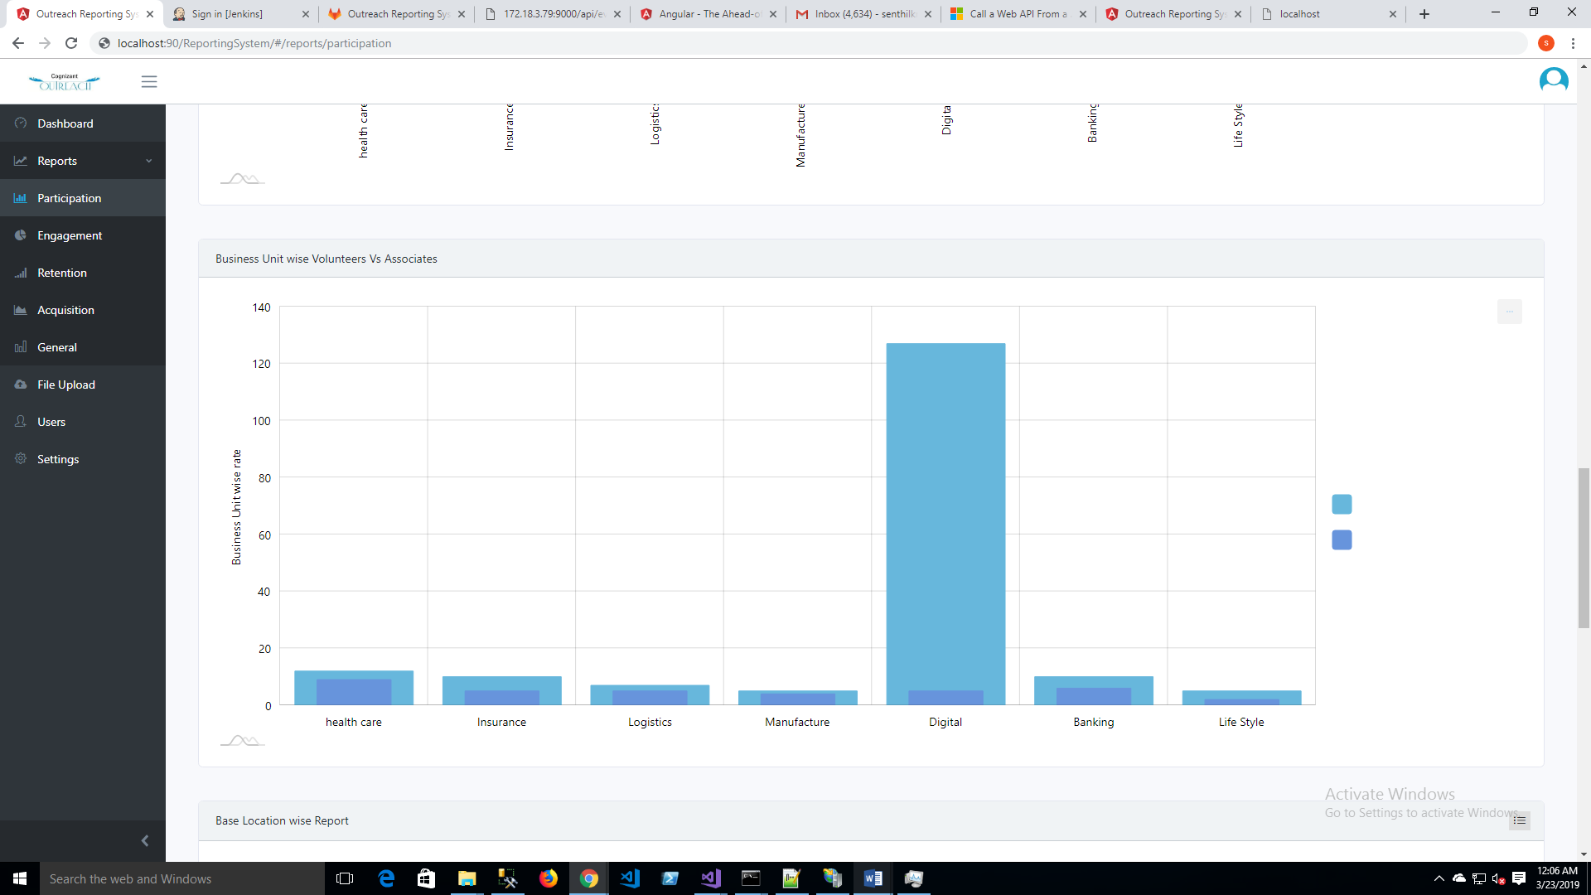

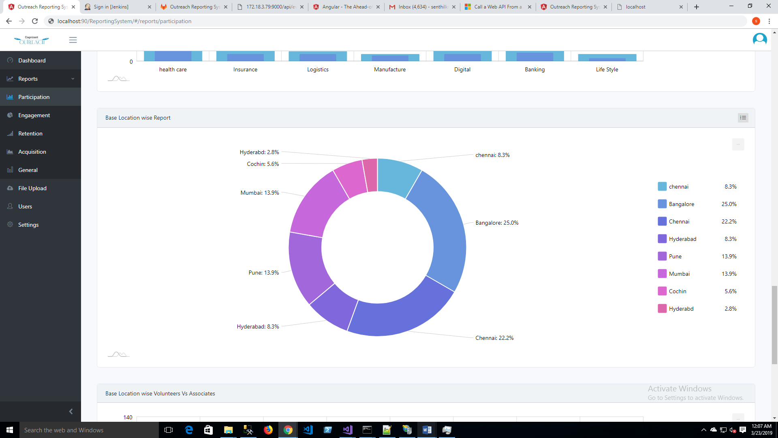

**Engagement Report Screen:**

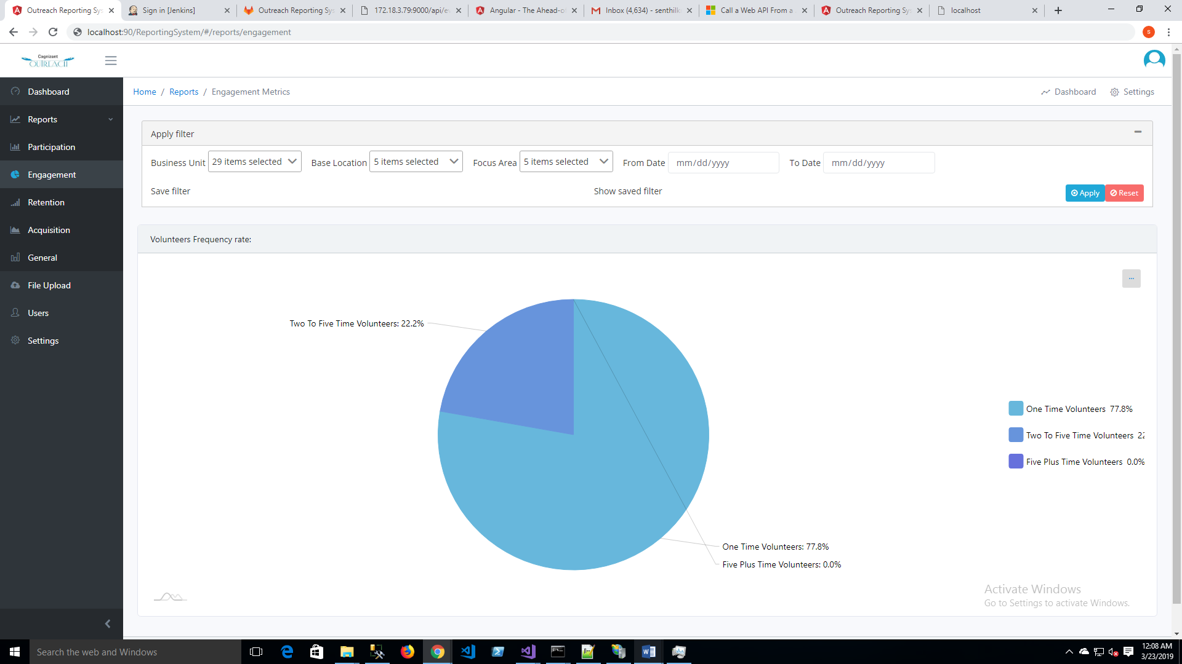

**Retention Report Screen:**

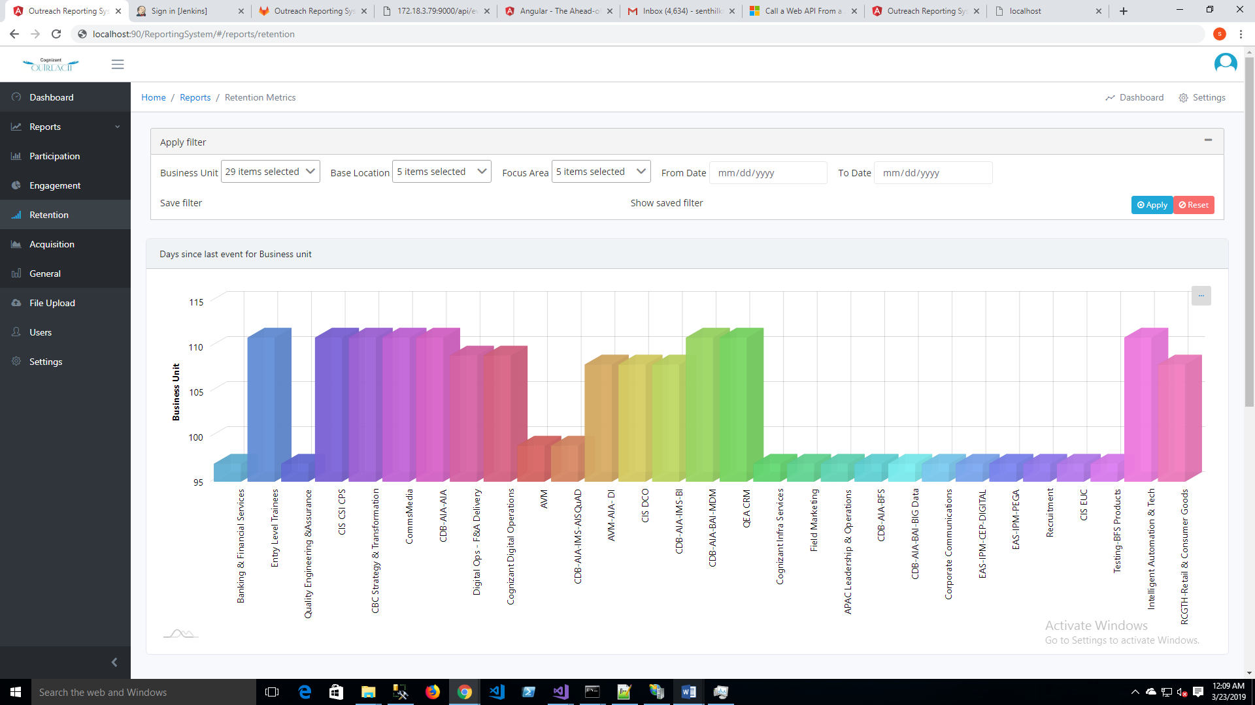

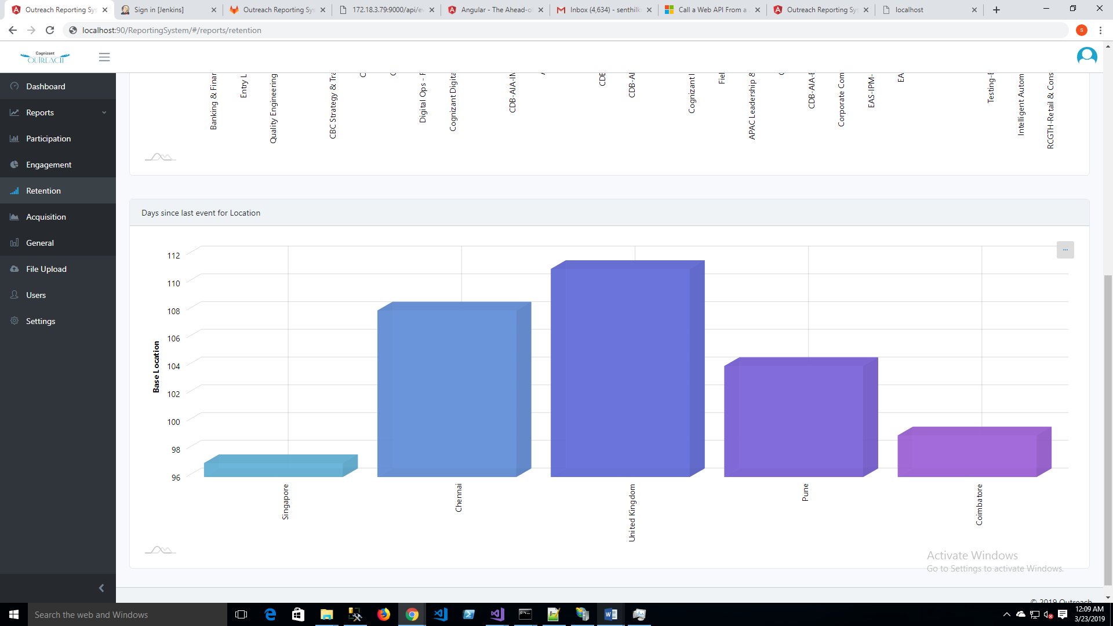

**Acquisition Report Screen:**

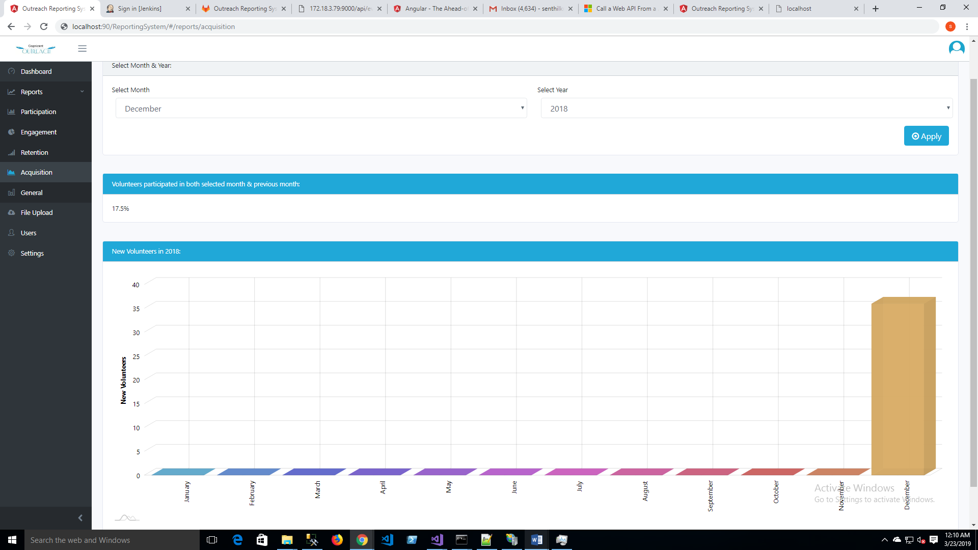

**General Report Screen:**

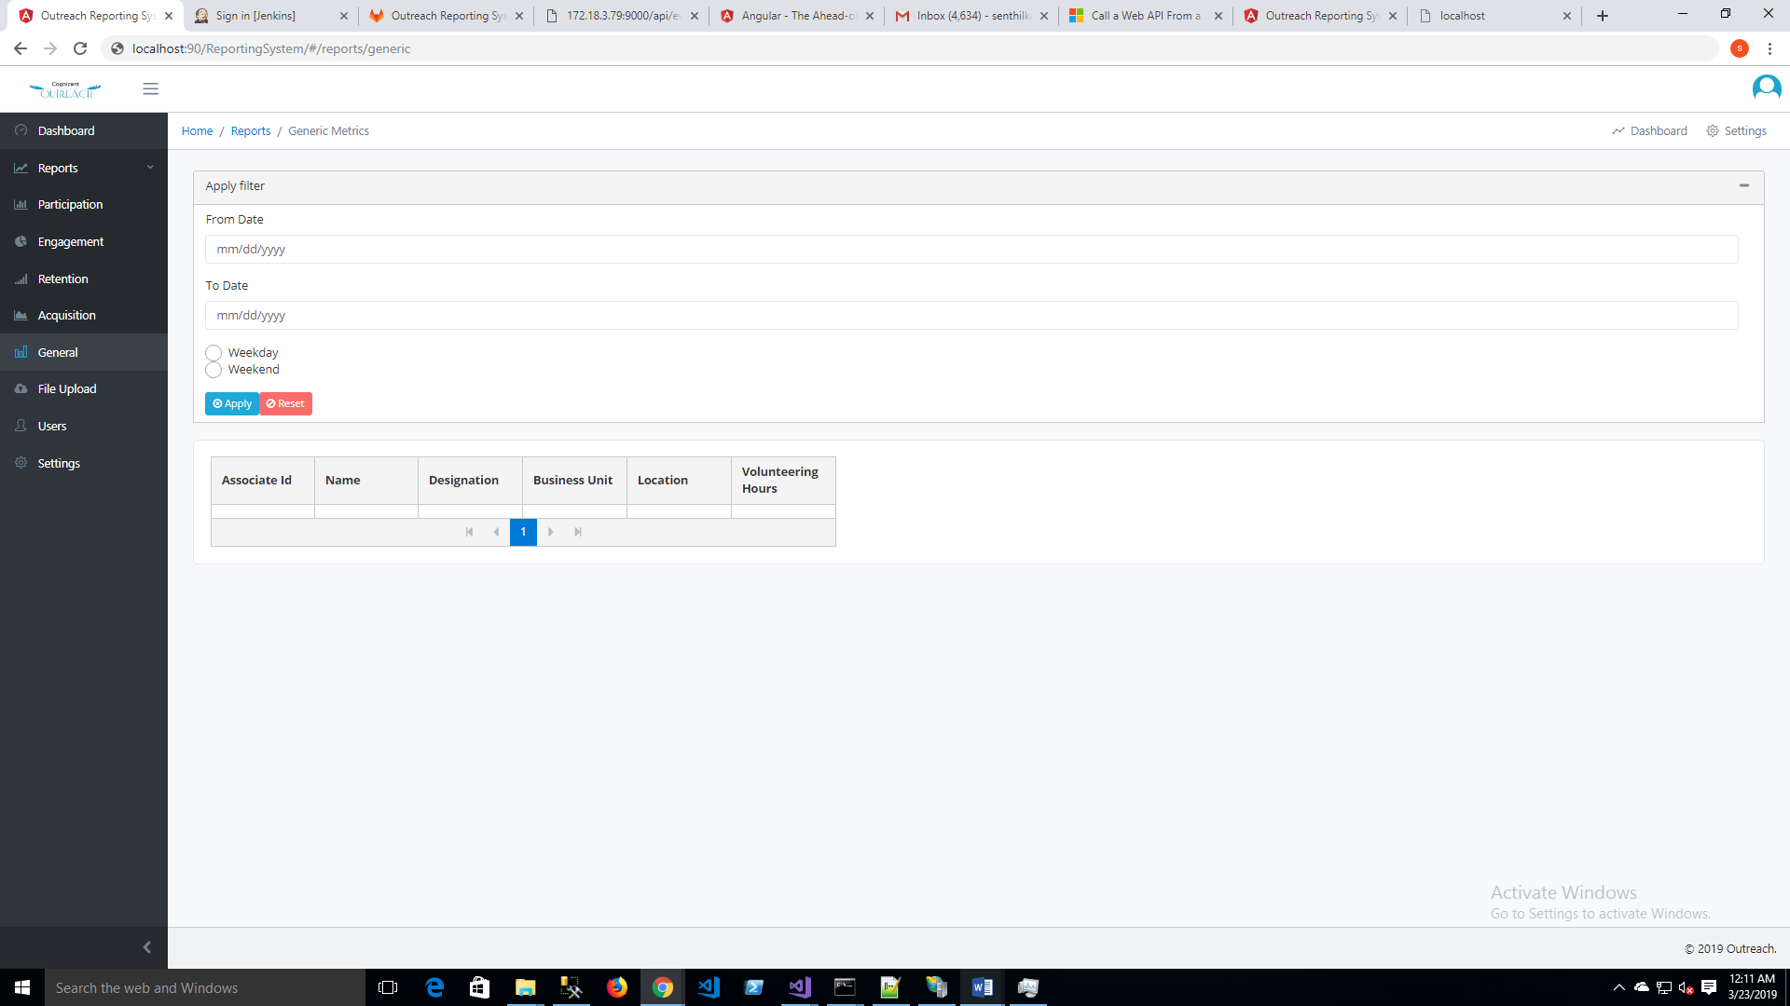

**File upload Screen:-** Only admin user can access this page: Admin user can provide input through this UI or put files in shared path.

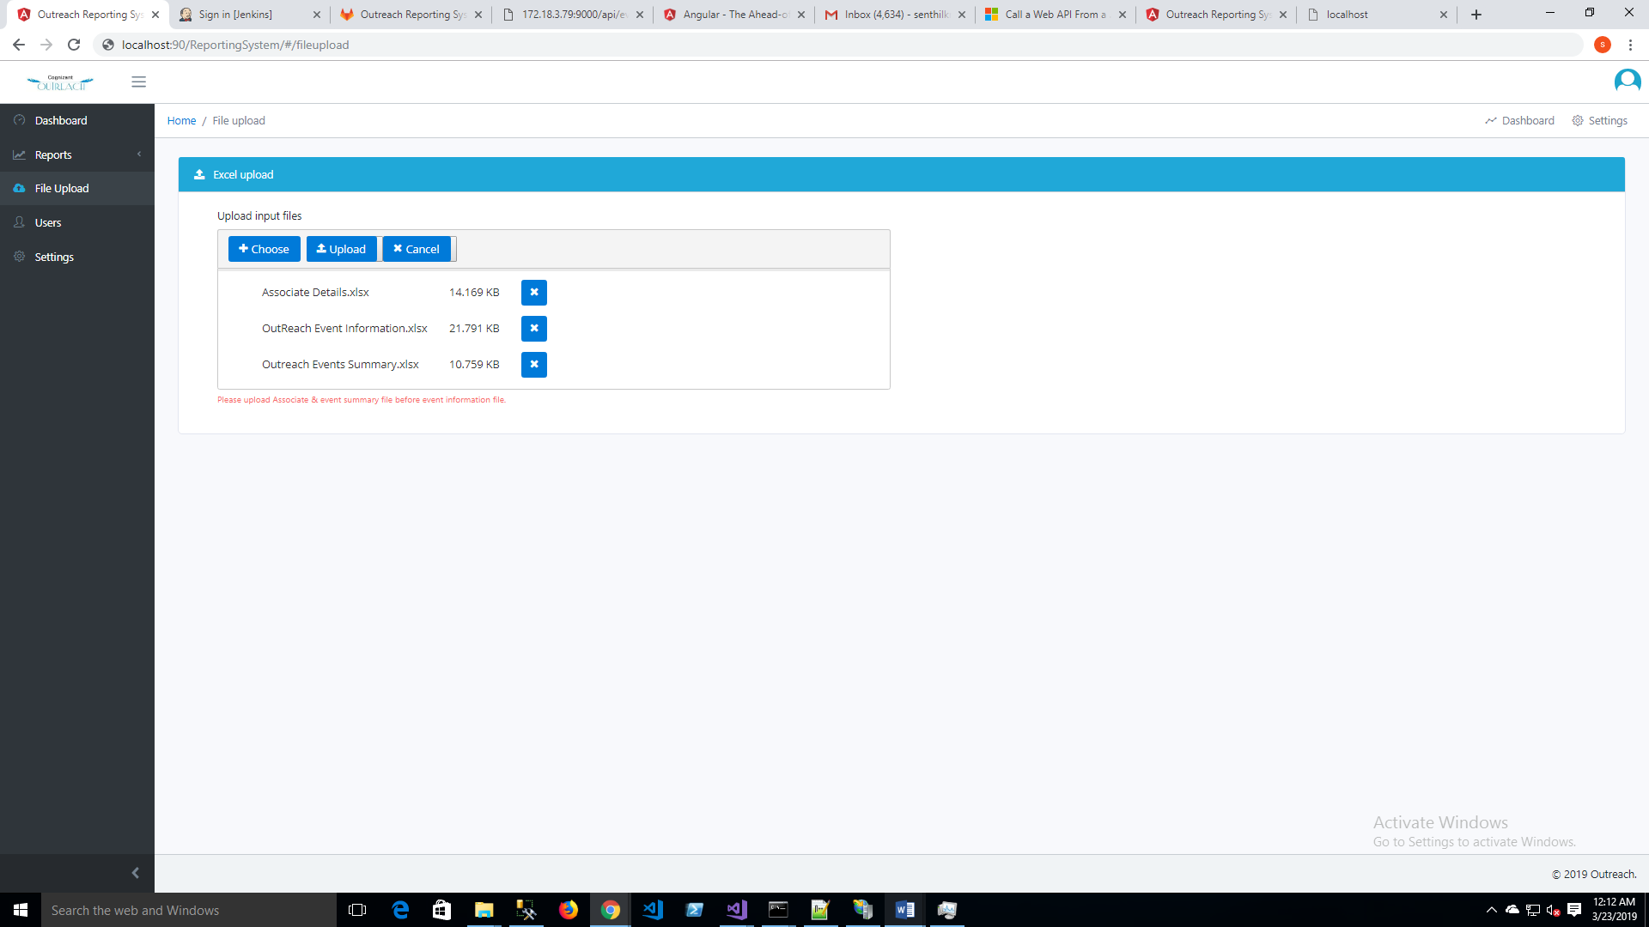

**Add application users screen:** only admin user can access

Admin user can add single or bulk users.

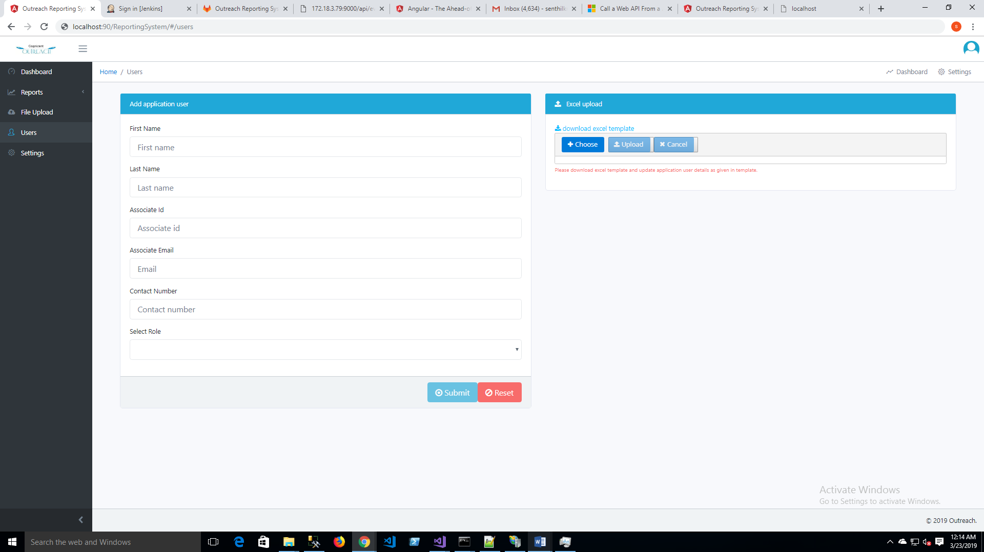

**Database Design:**

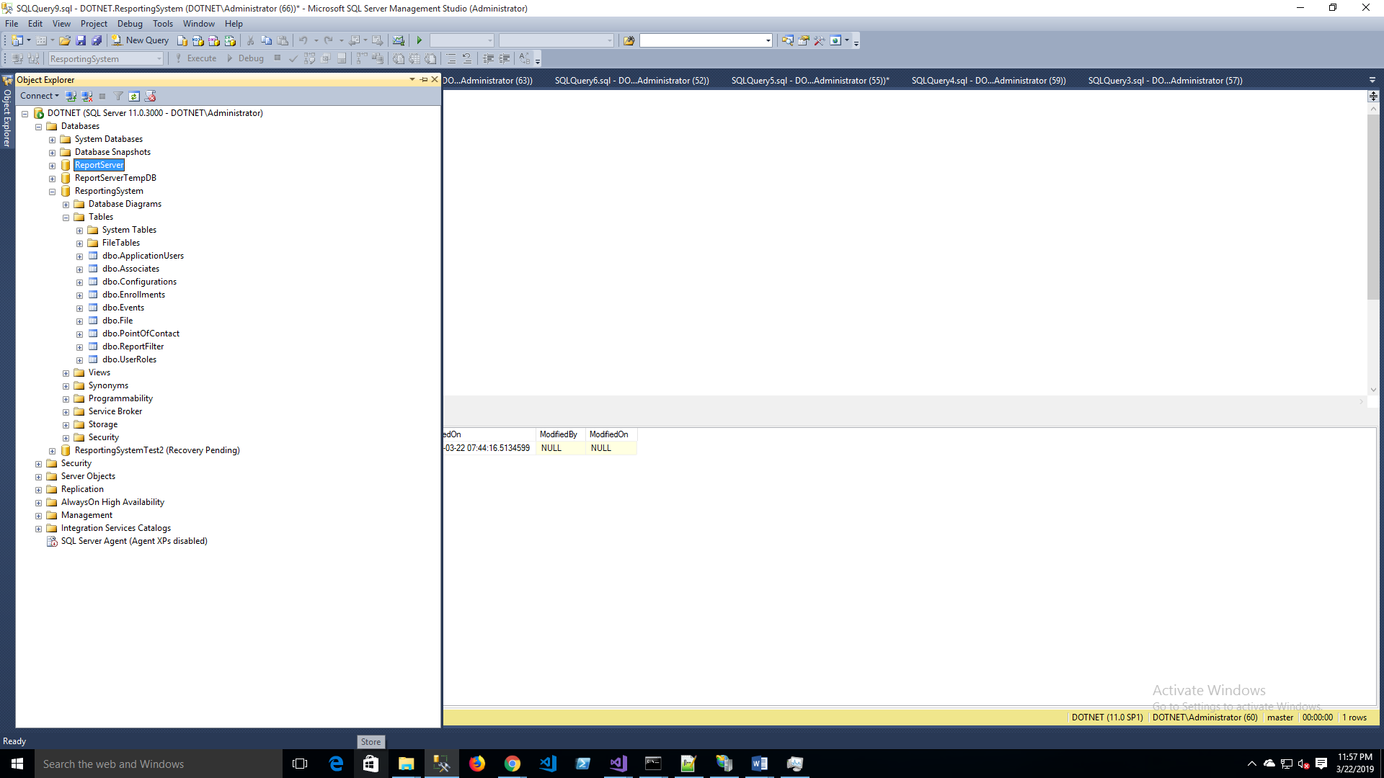

**Backend structure:**

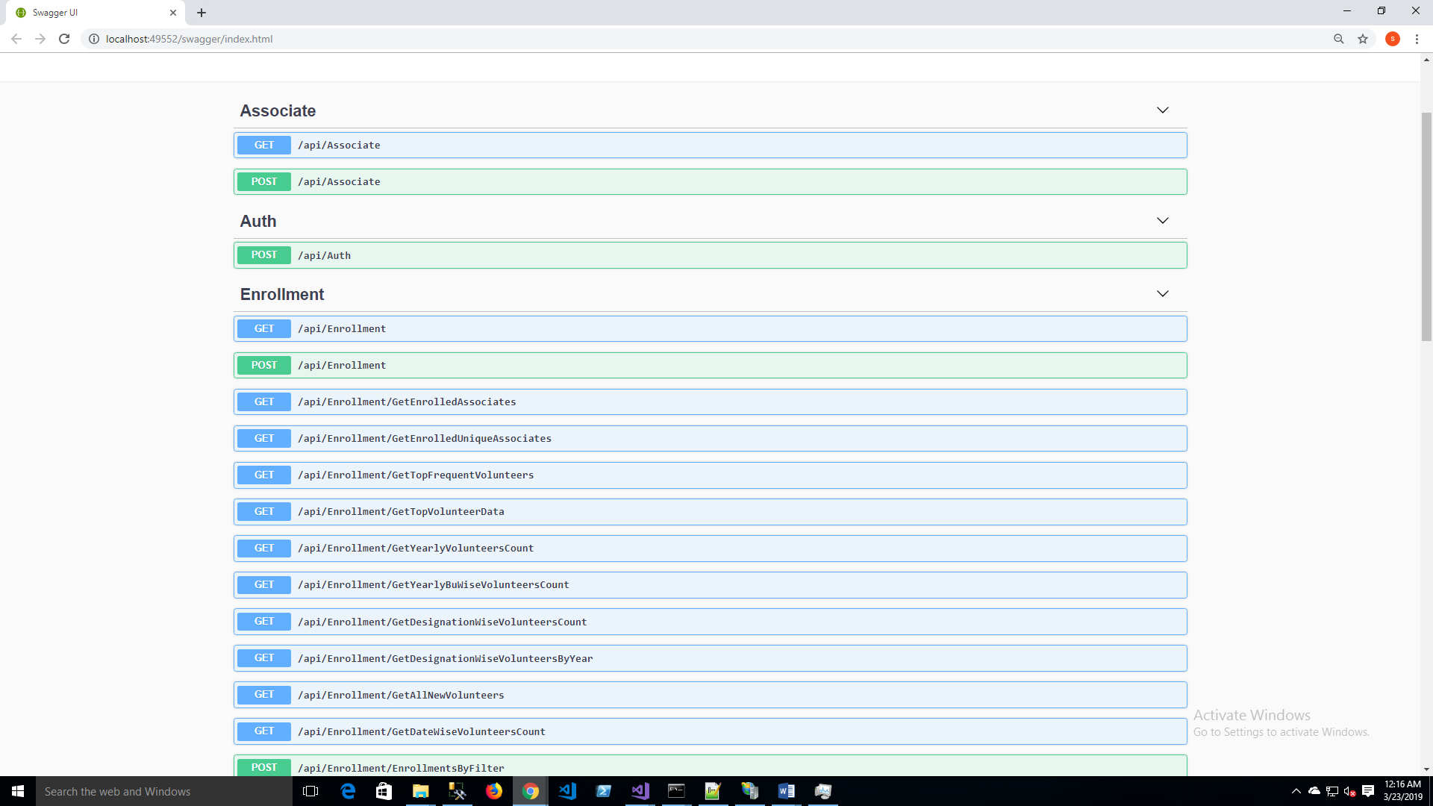

**Solution Architecture:**

This is a data driven application, so repository factory pattern with unit of work structure used.

